**React native components - User Interface**

**Button:**

* Buttons are touchable elements used to interact with the screen.

* They may display text, icons, or both. Buttons can be styled with several props to look a specific way.
* If this button doesn't look right for your app, you can build your own button using TouchableOpacity or TouchableWithoutFeedback.
* **Types of Button in React Native:**
* **Basic Types:** These fall into the basic category and can be of the following types:
  + **Button:** It is used for defining click buttons.
  + **Submit:** This type of button is used along with a form to submit details.
  + **Reset:** It is used to clear field contents on click of it.
* **Flat Button:** It has a style of no background color. To create a flat button in react, set CSS class to e-flat.
* **Outline Button:** This type of button contains a border with a transparent background. To create this type of button, set the CSS class as an e-outline.
* **Round Button:** This button is in a circular shape. To create a round button set CSS class to e-round.

|  |  |  |
| --- | --- | --- |
| **Property Name** | **Type** | **Use** |
| **onPress** | function | This is a required property, and it requires specifying  the function that will be executed when this button is  clicked. |
| **Title** | String | This is the text that would be displayed as a label on  the button, and this is a required property. |
| **Color** | Color | It is an optional property required to set the  background color of the button. |
| **Disabled** | boolean | It is used to disable touch events of a button. |
| **textID** | String | It is an optional property required to identify a button  uniquely. |

**Ex:**

import React from 'react';

import {Alert, Button, Text, TextInput, View} from 'react-native';

export const Login = () => {

    return (

        <View>

            <Text style= {{color: 'black', marginLeft:50, marginTop:60, fontSize:15}}>Email</Text>

            <TextInput style= {{color:'rgba (167,167,167,1)',marginLeft:50, marginTop:5,fontSize:14,margin:10,borderRadius:10,borderWidth:1}} placeholder="Enter your EmailId" ></TextInput>

            <Text style={{color: 'black',marginLeft:50,marginTop:1,fontSize:15}}>Password</Text>

            <TextInput style={{color: 'rgba(167,167,167,1)',marginLeft:50,marginTop:5,fontSize:14,margin:10,borderRadius:10,borderWidth:1}} placeholder="Enter your Password" ></TextInput>

            <View style={{alignItems:"center"}}>

            <Button

                title="Submit"

                onPress={() => Alert.alert('Working')}

             />

             </View>

        </View>

    );

};

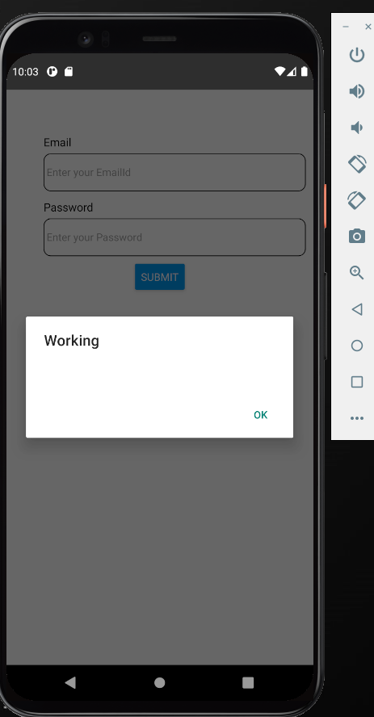

**TouchableOpacity:**

* TouchableOpacity means when we touch something, it will fade out a little bit to show the user have touched.
* Button doesn't look right for your app; you can build your own button using TouchableOpacity.
* With the help of TouchableOpacity we can navigate from one screen into another Screen.

import React, {useState} from 'react';

import {Stylesheet, Text, TouchableOpacity, View} from 'react-native';

export const Login = () => {

    const [count, setCount] = useState (0);

    return (

      <View style={styles.container}>

        <View style={styles.countContainer}>

          <Text>Count: {count}</Text>

        </View>

        <TouchableOpacity

          style={styles.button}

          onPress = {() => {setCount (count => count + 1)}}

        >

          <Text>Press Here</Text>

        </TouchableOpacity>

      </View>

    );

  };

  const styles = StyleSheet.create({

    container: {

      flex: 1,

      justifyContent: "center",

      padding: 40

    },

    button: {

      alignItems: "center",

      backgroundColor: "powderblue",

      padding: 10

    },

    countContainer: {

      alignItems: "center",

      padding: 10

    }

  });

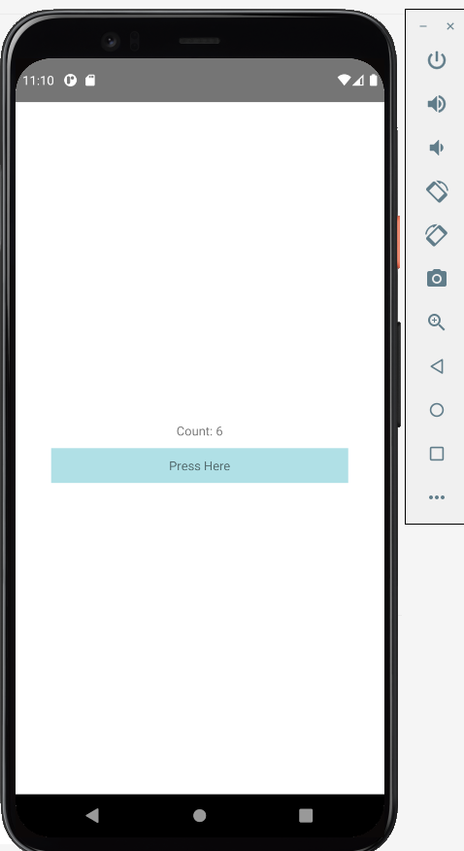

**Keyboard Avoiding View:**

* **Keyboard Avoiding View** is used to close the keyboard.
* It wraps the whole form that we made using TextInput and close the keyboard if touched outside the TextInput.
* It is very helpful in the case of IOS because it does have a back button to close the keyboard.

import React from 'react';

import {Alert, Button, Keyboard, KeyboardAvoidingView, Text, TextInput, TouchableWithoutFeedback, View} from 'react-native';

export const Login = () => {

    return (

        <KeyboardAvoidingView

      behavior={Platform.OS == 'ios' ? 'padding' : 'height'}>

        <View>

            <Text style= {{color: 'black', marginLeft:50, marginTop:60, fontSize:15}}>Email</Text>

            <TextInput style= {{color:'rgba (167,167,167,1)',marginLeft:50, marginTop:5,fontSize:14,margin:10,borderRadius:10,borderWidth:1}} placeholder="Enter your EmailId" ></TextInput>

            <Text style={{color: 'black',marginLeft:50,marginTop:1,fontSize:15}}>Password</Text>

            <TextInput style={{color: 'rgba(167,167,167,1)',marginLeft:50,marginTop:5,fontSize:14,margin:10,borderRadius:10,borderWidth:1}} placeholder="Enter your Password" ></TextInput>

            <View style={{alignItems:"center"}}>

            <Button

                title="Submit"

                onPress={() => Alert.alert('Working')}

             />

             </View>

        </View>

        </KeyboardAvoidingView>

    );

};